***Assignment 1***

***Vignesh S***

***20BCE1782***

***Vellore Institute of Technology , Chennai***

1. **Download tableau desktop & Mysql in your PC or laptop**

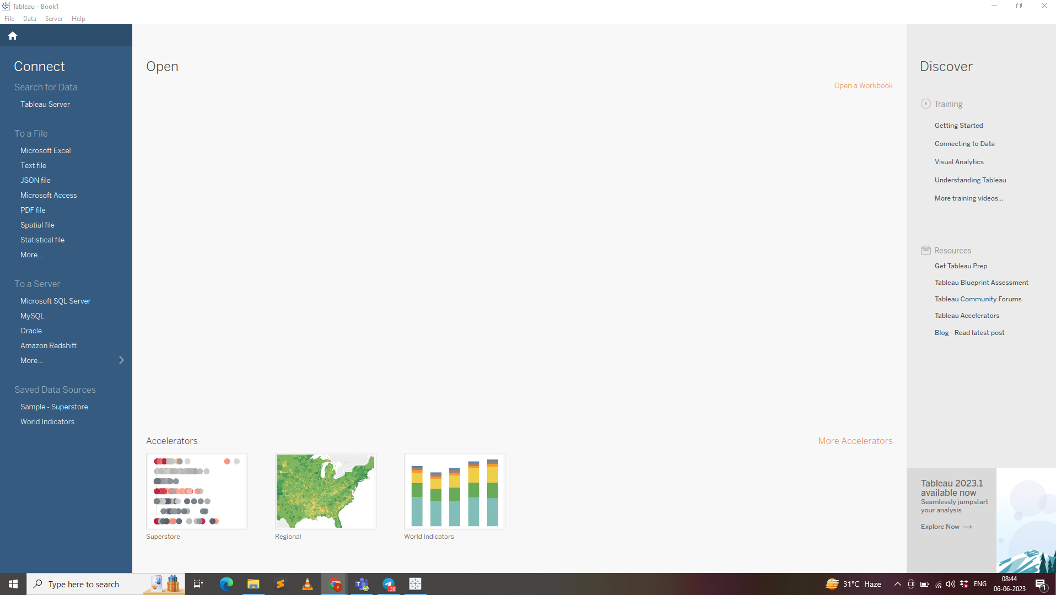

1. **Download tableau desktop & Mysql in your PC or laptop**

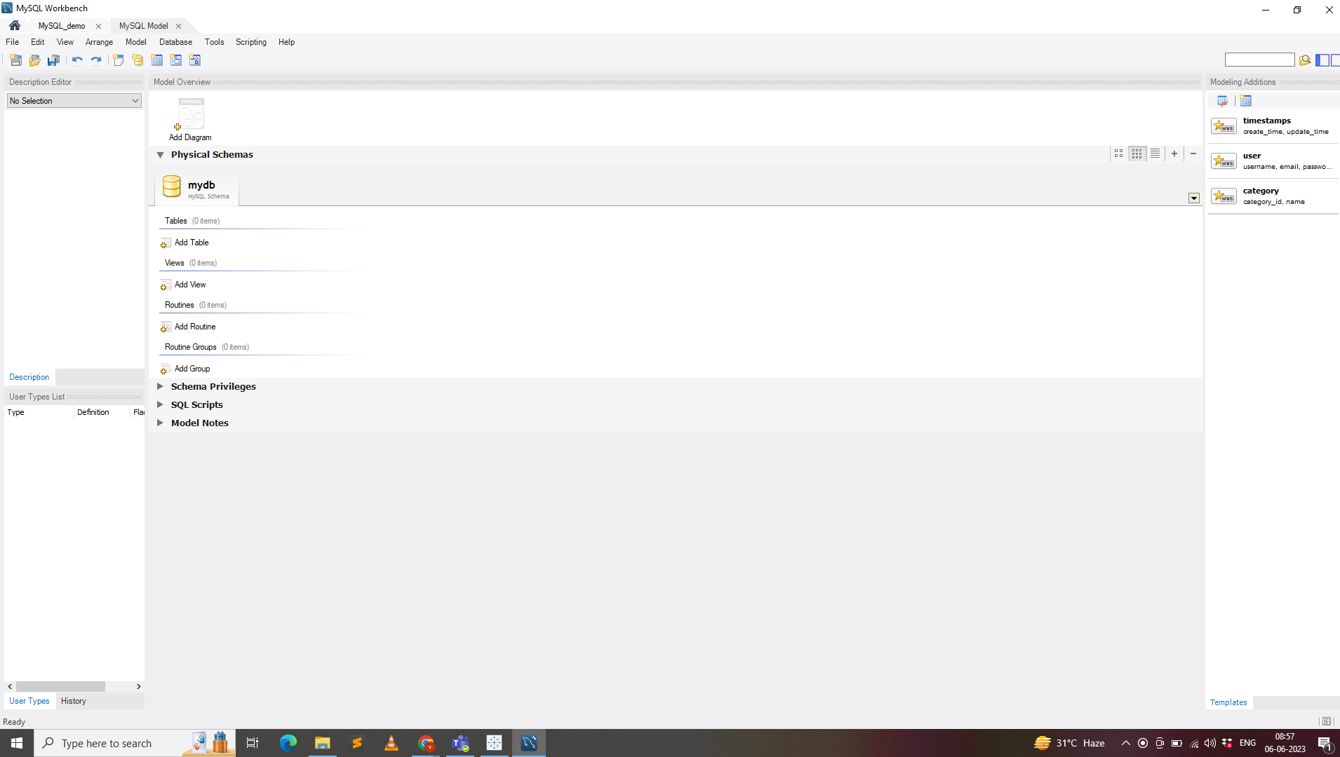

1. **Connect your Mysql and Tableau**

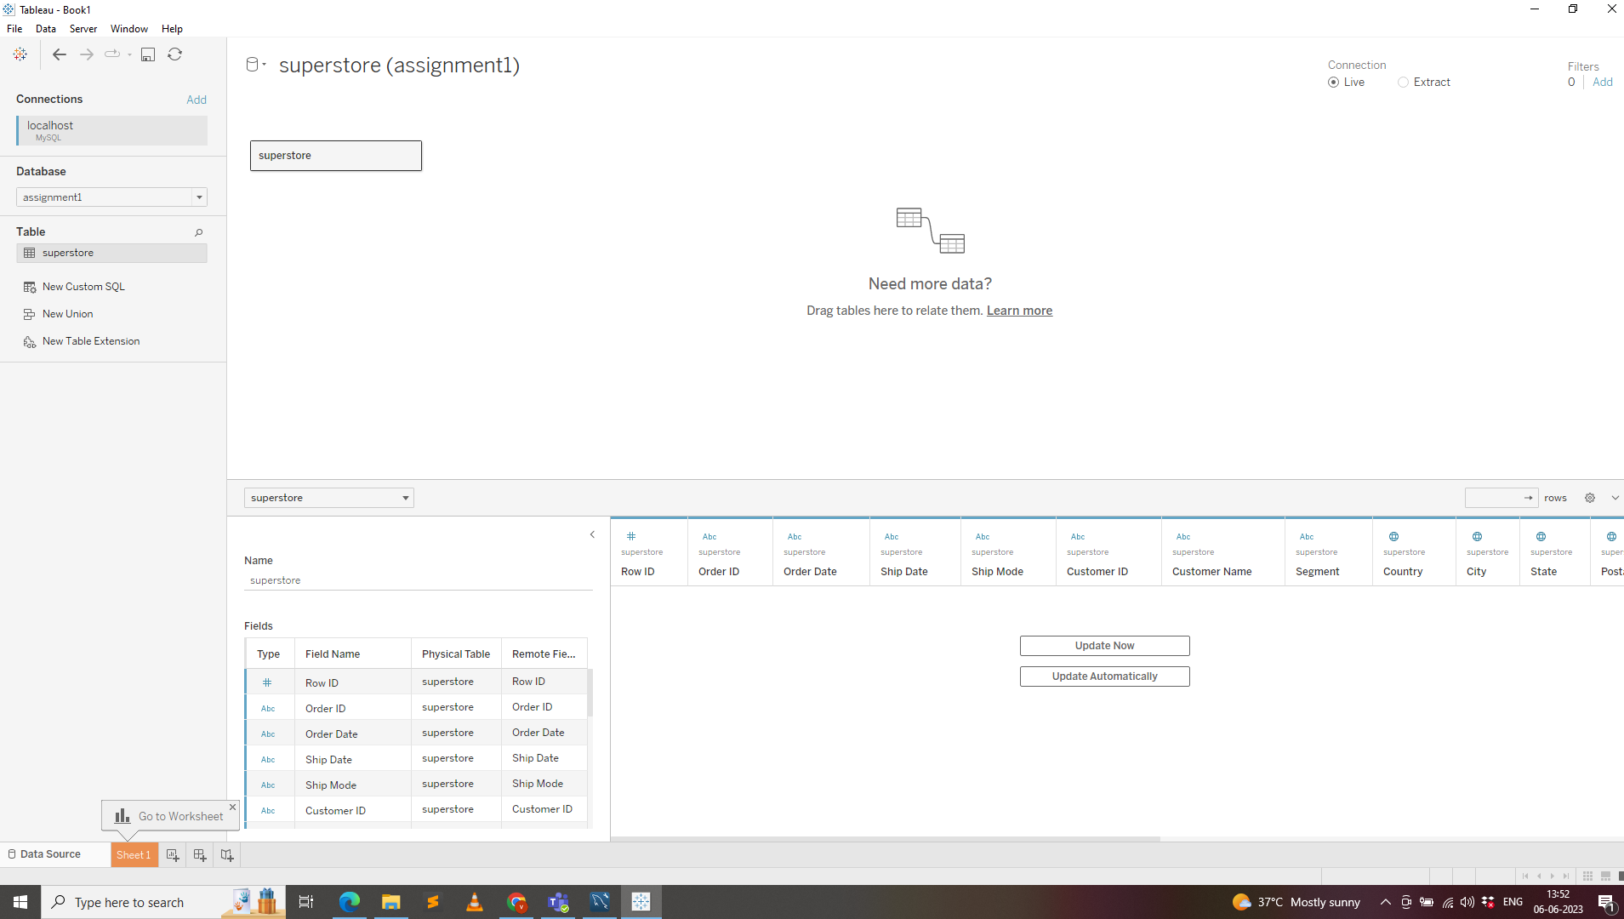

4) Create the below 5 charts/plots

● Bar chart

● Tree map

● Heatmap

● Pie chart

● Horizontal bar chart

